**AIR CADET PUBLICATION (ACP) 2**

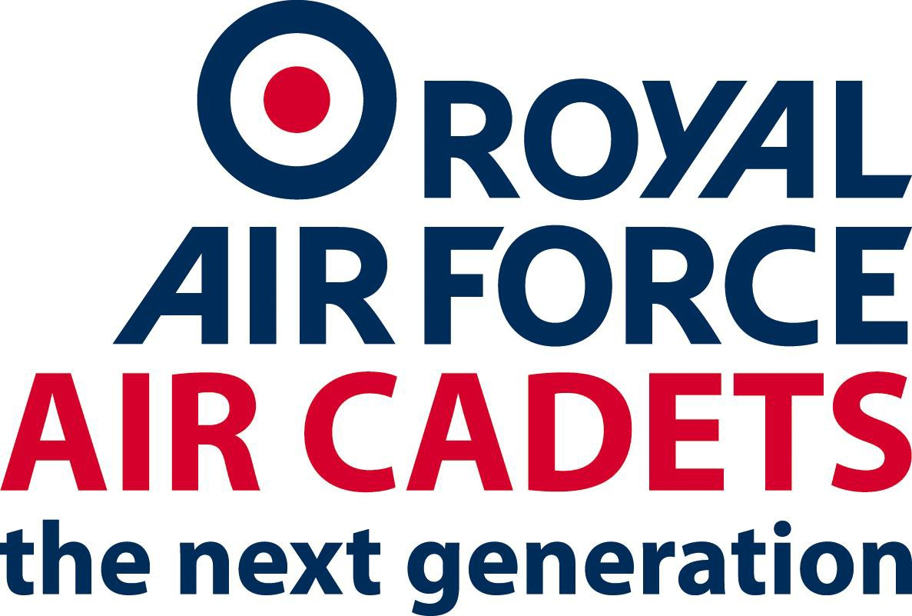

**A GUIDE TO CULTURAL**

**AND RELIGIOUS DIVERSITY**

|  |  |  |  |
| --- | --- | --- | --- |
| **Date** | **Amendment** | **Amended by** | **Version No** |
| 19/02/2016 | Standardisation on all ACOs to include amendment sheet | J Stones | 1.02 |
| 19/04/21017 | Update ACO to RAFAC | J Stones | 3.00 |
|  |  |  |  |
|  |  |  |  |
|  |  |  |  |
|  |  |  |  |
|  |  |  |  |

**FOREWORD**

This information has been taken from the Ministry of Defence Cultural

Awareness and Major Religious Guide.

The RAFAC’s commitment to equality and diversity is about including everyone. We want to make the most of differences in people, for the benefit of the Organisation’s effectiveness and the society we live in. Raising awareness of differences helps us to treat each other, and those with whom we deal, with respect and fairness.

This brief guide is designed to give you a better understanding of the many cultures and religions which can be found in the UK - and the RAFAC - today. It cannot hope to cover such a vast subject comprehensively. And we should not assume that all people from ethnic minorities will fit neatly into the categories described in this booklet. But we hope you will find it a useful addition to your knowledge and understanding.

**List of Contents**

Key facts and figures………………………………………………………………4

Terminology…………………………………………………………………………5

Faiths and Religions………………………………………………………………..8

Buddhism………………………………………………….8-9

Christianity………………………………………………10-11

Hinduism…….………………………………………….12-13

Islam……………………………………………………..14-15

Judaism……………………………………………………..16

Rastafarianism……………………………………………..17

Sikhism……………………………………………………...18

**Key facts and figures**

1. In 1991, people from Ethnic Minority (EM) groups (all groups who con- sider themselves distinct from the majority in terms of ethnic or cultural identity) comprised 5.5% of Great Britain’s population. It is estimated that EM groups now represent 8.69% of the UK population ie over 5 million people.

2. Whilst the EM population in the UK has increased over recent years, it is likely to stabilize at around 10% of the total UK population, say 5.5 million, over the next 25 years.

3. Nearly half are South Asians with Indians being the largest single EM group (24%) of all EM people) followed by Parkistanis (17%) and Black Caribbean’s (13%).

4. Population distribution varies greatly with highest concentrations in urban and metropolitan areas – particularly London and the West Midlands, where people from EM backgrounds make up 28% and 18% of the local populations.

5. The age profile is much younger, 33% of EM people are under 16 compared with 19% of white people, and only 3% are over 65, compared with 17% of White people.

6. 47% of the UK’s EM population were born here, with black people having the highest rate of UK birth. There is a sharp differential by age: 80% of under 25s were born in the UK compared to only 15% of over 25%.

7. During WWII some 2.5M Indians enlisted in the UK Armed Services. 160,000 Africans also served. 300 West Indians served as RAF Aircrew and 5,500 on ground duties. 14,000 Jews served in the RAF.

8. Ethnic minority percentages in the UK Armed Forces as at 1 July 2004, Officers and Ors

RN - 2.4%

Army - 7.1%

RAF - 2.5%

**Terminology**

1. The best way of describing a person of EM background, or indeed any person is how they would prefer to be described. You cannot go wrong if you

a. Refrain from making assumptions bases on stereotypes or misinformation

b. Take the initiative to find out about different local cultures and religions.

c. If in doubt ask. A courteous and well-judge inquiry about how to pronounce a name or about a specific religious belief will not be offensive.

d. Be aware of inappropriate, dated or offensive works. Language and terminology are constantly evolving. Some words that were once acceptable no longer are.

(1) *Individual preferences will vary but the following provides guidance about how to refer to different EM groups.*

2. **Ethnic** – Refers to race and culture. It is distinct from nationality, place of birth, language or religion though it may be related to all of these. Race refers to one’s physiological characteristics whereas Ethnicity is part of one’s cultural and social characteristics. ‘Ethnic minority’ is the term widely used, and generally acceptable. Reversing the order to ‘minority ethnic’ communities is also used to emphasise that the majority as well as the minority has an ethnic identity. ‘Racial minorities’ is also an acceptable alternative to ‘ethnic minorities’. The word ‘Ethnics’ by itself should be avoided.

3. **Asian** – In general people prefer to identify themselves by their national origin (eg Indian, Pakistani and Bangladeshi), their region of origin (eg Gujarat, Punjab, Bengal) or their religion (eg Muslim, Hindu or Sikh). Some who are born in Britain will describe themselves as British or British Asian. The ter ‘Asian’ is geographically confusing since it ought to include Chinese but does not. ‘Asian’ or ‘British Asian’ is acceptable where the exact ethnic origin of the person is not known, or as a collective reference to people with origins in the person is not known, or as a collective reference to people with origins in the Indian subcontinent.

4. **Black** – In general, it is acceptable to describe people of Caribbean or African origin as ‘Black’. Some people from the Indian subcontinent may also accept this while others do not – and may indeed strongly object to it. It is, therefore, best not to use the term ‘Black’ to refer collectively to people from Asian origins and it is preferable to say ‘Bland and Asian people’. People born in Britain may prefer to refer to themselves as ‘Black’ or ‘Black British’.

5. **African** – Acceptable and may be used in self-identification, although many of those of African origin will refer to themselves in national terms such

as ‘Nigerian’, ‘Ghanaian’, etc.

6. **African-Caribbean** – Widely used and acceptable to most people of that ethnic origin. Some consider it preferable to ‘West Indian’ or ‘Afro-Caribbean’.

7. **Mixed-Race** – The term ‘mixed race’ is widely used, however, it can carry negative connotations. It may be preferable to refer to a person as being ‘of mixed parentage’ or to use the term ‘multi-racial’, eg in referring to a ‘multi-racial household’). Newer terms to be aware of are ‘duel heritage’ and ‘joint ethnicity’.

8. **British** – Care should be taken to use the term ‘British’ in an inclusive sense, ie so that it includes all inhabitants or citizens of our multi-racial, multi-cultural society. Exclusionary use of the term as a synonym for ‘White’, ‘English’ or ‘Christian’ is not acceptable. Similarly, ‘English’ should not be used where ‘British’ is meant (eg when the group includes Scots, Welsh, Irish).

Examples of terminology that is unacceptable and should not be used are.

a. **Coloured** – This once commonly used term is **now generally disliked** and felt to be outdated or patronising.

b. **Half-Caste** – The term ‘half-caste’ is **generally found offensive** and should be avoided.

c. **Non-White** – This suggest a **negative value judgement** and should not be used.

d. **People of Colour** – Common in the USA but **not here in the UK**.

e. **Negro/Negroid – Not acceptable**.

f. **Oriental – Not acceptable** as it is imprecise and may be found offensive. The proper name such as Chinese, Malaysian, Vietnamese etc should be used.

g. **Ethnics** – An **offensive and exclusionary** term which should not be used.

h. **Immigrants** – It is **inaccurate and offensive**, when applied to racial minorities in general, as many EM people are British born.

i. **Christian Names** – It is often **more appropriate** to ask for a **First Name** rather than Christian name.

j. **Offensive Nicknames** – There are numerous terms and ‘nicknames’ which until recently were routinely applied to members of the minority ethnic populations, which are now considered offensive and unacceptable. The **use of such language in the workplace is**

**likely to be in direct contravention of RAF (MOD, RN and Army) policy, race-discrimination and employment legislation**. It is MOD policy to have zero tolerance of the use of racist, offensive or demeaning language.

**Faiths and Religions**

1. In all religions, there is a range of orthodoxy and observance – some are devout, others only practice for festivals and rites of passage (eg births, marriages and deaths); others are aware of family tradition, but do not personally have faith at all.

2. The main faiths and religions practised in the UK are Buddhism, Christianity, Hinduism, Islam, Judaism, Sikhism and Rastafarianism.

**Buddhism**

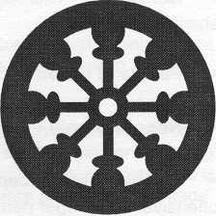

3. **Buddhism** – founded around 2500 years ago by **Prince Siddhartha Guatama** in northeast

India. The prince abandoned his privileged life in the city to search for the meaning of suffering. He experienced enlightenment under the **Bodhi Tree** – now a scared symbol

of Buddhism – returned to the city and became

known as **Buddha** – the awakened one. He created the **Sangha**, a community of monks and nuns to teach **Dharma**, his teachings on the way to

achieve enlightenment. Buddhists do not explicitly state a belief in God, nor do they deny belief. They believe in Buddha’s readings, which are embodied in the 4 noble truths:

a. Human life is full of suffering

b. People create suffering because they are attached to desire or selfishness

c. If selfishness and desire are destroyed, suffering will cease d. The eightfold path is a guide, which will lead to an end of

suffering – it is sometimes symbolised as an 8-spoked wheel known as

the **Dharma Chakra** or Wheel of Truth. The eightfold path is: **the right**

**views** (a positive mind to think of the good things in you and others); **the right thoughts** (care for others); **the right speech** (do not tell lies or say hurtful things); **the right action** (do not kill, cause injury or steal); **the right livelihood** (in your job do not cheat or cause harm); **the right effort** (follow this eightfold path); **the right mindfulness** (be aware of thoughts and actions); **the right concentration** (the peaceful state of mind that you would gain having followed the eightfold path).

4. There are a number of Buddhist holy books (an example is the Pali Canon, which is written in Sanskrit, Tibetan and Chinese). Buildings dedicated to worship vary. A shrine maybe in a home or in a temple where Buddhists will take offerings of flowers, fruit, incense and water. It is respectful to remover your shoes when visiting a Buddhist shrine. Most Buddhists are vegetarian due to the need to avoid intentional killing. There is

no particular dress worn by Buddhists; clothes are reflective of the different cultural backgrounds of the followers although some Buddhist monks wear special recognisable robes. Significant holy days are:

a. **Wesak – Buddha day**: May – June full moon. Commemorates the birth, enlightenment and passing away of Buddha.

b. **Uposatha days**: Any new or full moon days are sacred.

c. **Sangra day**: November (a global celebration day for Buddhists)

d. **Dharma day**: July full moon – celebrates the teachings of

Buddha and Wheel of Truth.

**Christianity**

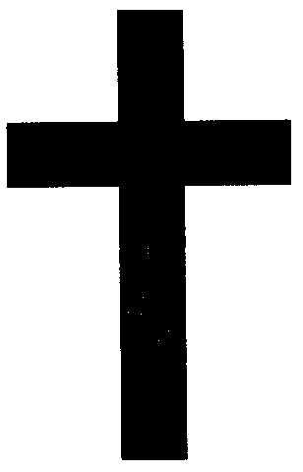

1. **Christianity** – founded around 2000 years ago by followers of **Jesus** of Nazareth. Christians live according to the loving nature of God revealed by the life and death of Jesus. There are many forms of Christianity, including **Roman Catholic, Eastern Orthodox and Protestant** churches. The latter has many denominations such as Anglican, Church of Scotland, Baptist, Methodist,

Quaker, Pentecostal and the United Reformed churches. Most Christians believe in the holy trinity, the **Father**, the **Son** (Jesus) and **the Holy Spirit** –

all have equal and divine status. Jesus is believed to be the Son of God, born of the virgin Mary, who is particularly important to Roman Catholics and the Eastern Orthodox churches. The Christian holy book is the **Bible**. Consisting

of the **Old** and **New Testaments** which describes the creation of the universe, the origins of Christianity, the life of Jesus and his teachings and the end of time. There are few dietary or dress restrictions for Christians, although some associate Friday with eating fish and some impose restrictions on certain

foods during Lent.

2. There are also many black Christian churches that were formed in areas of the USA, and latterly in the UK, which reflect the traditions and customs of the church in Africa and the Caribbean.

3. Significant holy days are:

a. Sunday is the traditional day of worship and rest.

b. **Palm Sunday** – the Sunday before Easter celebrating Jesus’ entrance into Jerusalem where he was greeted by crowds waving Palm leaves.

c. **Maundy Thursday** – commemorates the last supper before

Jesus was crucified.

d. **Good Friday** – the crucifixion; it is said to be “good” because Jesus showed love and forgiveness and obeyed God’s will in offering himself as a sacrifice.

e. **Easter** – celebrates Jesus’ resurrection from the dead. Easter eggs are given symbolising new life.

f. **Whitsun/Pentecost** – celebrating the outpouring of the

Holy Spirit at the birth of the Church – 50 days from Easter.

g. **Ascension Day** – is celebrated 40 days after Easter and marks

Jesus’ return to God.

h. **Christmas Day** – celebrating the birth of Jesus. Gifts are exchanged between families and friends.

**Hinduism**

It

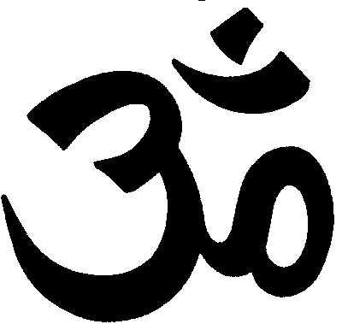

1. **Hinduism** began over 5000 years ago in India. is known as **Santana Dharma** – eternal truth in

the scriptures. There is no recognised founder. The fundamental belief is that the truth is with all

of us. For many Hindus, worship is centred on the home where the eldest

member of the family performs religious and ceremonial rites. Temple (called the **Mandir**) worship is, however, also important (shoes are not worn and the head should be covered but this is not essential). Hindus worship many gods but ultimately believe in one God. They believe that gods and men and women come from one eternal creative force and their aim is to be drawn back to the divine origin to be released from the need to be reborn.

Consequently, re-incarnation is of central importance in that their behaviour in this life determines their status in the next.

2. There are many Hindu holy books; **Vedas, Uprishad, Puranas** being examples. The **Caste system** is the Hindu hierarchy, which divides people into different groups, which can influence all aspects of life, particularly family matters and marriage. There are 4 groups: **priestly caste; warrior and ruling caste; farmer, merchants and craftsmen caste and the untouchables**. There is a lot of mis-understanding in Britain about the caste system. There was a time when each caste was exclusive and inter-marriage was strongly discouraged but nowadays the strict system has been gradually relaxed and caste is very rarely observed in the workplace.

3. Hindus are generally modest about their bodies and dress with respect and dignity. Traditionally many Hindu women wear **saris**; they may also wear a **shalwar** (loose trousers and tunic). Married women may wear a **bindi** (red powder spot on their forehead) but many younger women regularly wear western clothes. Hindu men usually wear western clothing. Eating meat is forbidden, particularly beef (the cow is sacred). Observant Hindus will neither eat fish or food containing eggs. There is also great emphasis placed on hygiene and methods of cooking and eating foot. Drinking alcohol and smoking are religiously and socially disapproved of.

4. Numerous ceremonies and celebrations surround Hindu birth, marriage (sometimes arranged by parents or relatives) and death. In the latter, Hindus are cremated and their ashes immersed in rivers, preferably the Ganges. A further ceremony is often held between the 13th and 15th day after death to assist the soul to its departure to its new life.

5. Holy days are:

a. **Raksha Bandham** – August, celebrating the bond between brother and sister.

b. **Dussehra** – October, commemorates when **Lord Rama** fought and defeated **King Ravana** – a 10-day celebration culminating in the burning of the image of King Ravana.

c. **Durga Puja** – October, involving 4 days of worship after which images of the warrior goddess Durga are immersed in rivers and lakes.

d. **Diwali** – October and November (although dates are based on the lunar calendar and not fixed), is a festival of lights celebrating **Lord Rama’s** return from banishment. Gifts are exchanged between families and friends.

e. **Holi** – March; a festival of colour.

**Islam**

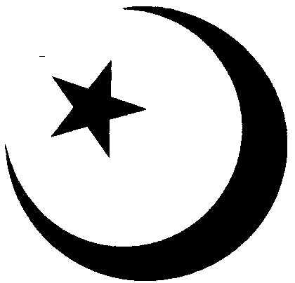

1. **Islam** began in the 6th Century AD. Islam is Arabic for surrender and in this context means to accept

the power of **Allah** and to follow his commands revealed to the prophet **Muhammed**. A believer

in Islam is known as a **Muslim**. Muslims believe

that Islam teaches the true and successful way of life in all respects (religious practice, morality, social, economic and political relationships, marriage, divorce, etc) for the whole human race. There are 5 pillars of Islam:

a. **Kalma** – declaration of faith; there is only one Allah or God and

Mohammed is his prophet.

b. **Salah** – 5 daily prayers at appointed times (before sunrise, noon, mid or late afternoon, evening and night) facing **Mecca** performed at a **Mosque** (shoes must not be worn and the head covered, although latter is optional for men) at home or at work.

c. **Ramadhan** – fasting during the month of Ramadhan

(pronounced Ramzan) before sunrise to after sunset each day. d. **Hajj** – pilgrimage to Mecca at least once during a lifetime.

2. Islam requires Muslims to dress modestly. Traditionally, women should cover their heads by wearing a scarf or **Hijab**, cover their bodies and avoid direct contact with unrelated males. Men often wear a **shalwar** and **kameez** (tunic) outside work but both sexes now often wear western clothing at work. Muslims will eat all meat, except pork, providing that it is **halal** meat killed in the Muslim manner. Alcohol is forbidden. Islam affirms the equality of men and women but roles for the sexes are different and free mixing socially is disapproved of. Marriages, traditionally, are arranged with the consent of both partners.

3. Holy days are:

a. **Muharram** – Islamic New Year.

b. **Ashura** – first month of the Muslim calendar.

c. **Milad-un-Nabi** – commemorating the birth and death of the

Muhammed.

d. **Ramadhan** – as above.

e. **Eid-ul-fitr** – feasting with friends and relatives after Ramadhan;

new clothes are worn.

f. **Eid-ul-Adha** – a 3-day festival that marks the end of Hajj.

**Judaism**

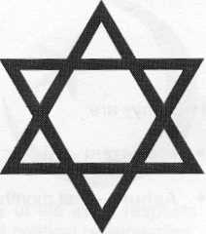

1. **Judaism** is over 4000 years old and the forebear of Christianity and Islam. There are

600K Jews living in the UK today, the majority belonging to **Orthodoxy** lead by the **Chief Rabbi**. The progressive Jewish community is Divided into Liberal and Reform Judaism. The Old Testament tells how the patriarch **Abraham**

embraced the worship of one God who revealed the laws, including the 10

Commandments and holy scriptures, to **Moses at Mount Sinai**. These teachings are contained in the Jewish holy book the **Torah**.

2. **Saturday** is the Jewish **Sabbath** and starts at sunset on Friday until nightfall on Saturday; devout Jews will not perform any “creative” work. Activities such as travelling by car or public transport, cooking, phoning or writing are forbidden, as is transacting business. Many Jews will pay in advance eg for a visit to a stately home or theme park, so that they can observe their religious requirements as far as possible, whilst fitting in with the British way of life. Devout Jews will pray 3 times per day.

3. Observant Jewish men wear a small skullcap at all times and many wear a **Tzitzith**, a tasselled garment. Some observant Jews may wear a beard – during certain periods of the religious calendar, shaving is not permitted. Acceptable food to the Jewish faith is known as **Kosher**. Food which may not be eaten include: fish without fins and scales, shellfish, pig and rabbit.

4. Holy festivals include:

a. **Pesach** – Passover (an 8-day festival) which marks the journey of Jewish people from slavery in Egypt.

b. **Rosh Hashnah** – Jewish New Year last for 2 days commemorating the creation of the world.

c. **Yom Kippur** – the most important holy day of the year, when fasting is observed.

d. **Hanukhah** – a celebration lasting 8 days representing the rededication of the Temple by the Macabees who led the war to defeat the Syrian invaders of Israel.

**Rastafarianism**

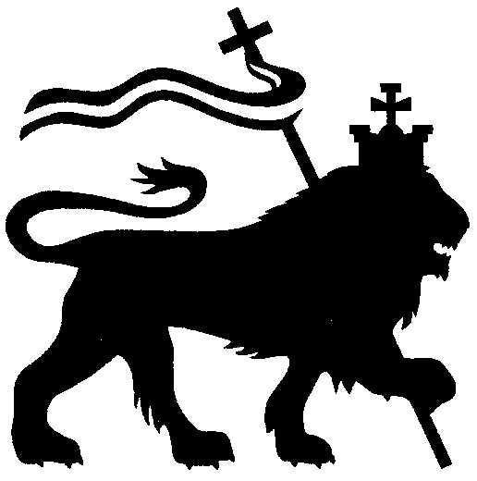

1. **Rastafarianism** originated in the 1930s in

**Jamaica** led by **Marcus Garvey**. The religion is based on the belief that **Haile**

**Selassie 1** (late Emperor of Ethiopia) is the

reincarnation of Christ and the goal of redemption is by repatriation to Ethiopia, which is the spiritual home of all black people.

2. The holy book is the **Bible**, particularly the **Old Testament** and the **Book of Revelation** in the New Testament. The principles of Rastafarianism are linked to Christianity and Judaism. There are various Rastafarian groups: the **12 Tribes of Israel; Nyabingi; Ethiopian Orthodox Church; Ethiopian World Federation**. The term “I and I” is used as a form of greeting and also to stress unity. Rastafarians will often dress in the colours of the Ethiopian flag: **red** signifying the bloodshed of their historical struggle; **gold** for faith, prosperity and sunshine; **green** signifying the land of Ethiopia and **black** the colour of the people.

3. Both men and women normally wear their hair in **dreadlocks** as the symbol of the lion’s mane and the **Masai warriors** of Ethiopia; the hair should not be cut. When worshipping the head should be covered with a **Tam**, a knitted leather or cloth crown. Most Rastafarians are vegetarians and eat Ital food (natural and cooked without salt). They do not drink alcohol, tea or coffee. Rastafarians regard the smoking of cannabis as permissible as it is thought to enhance wisdom and facilitate meditation and prayer. However, the law of the land and Service regulations do not permit any usage of the drug cannabis. There is no name for their place of worship and often this takes place in the home.

4. Holy days are:

a. **23 July** – the birthday of Haile Salassie 1. b. **11 Sept** – Ethiopian New Year’s day.

c. **7 Jan** – Ethiopian Christmas.

**Sikhism**

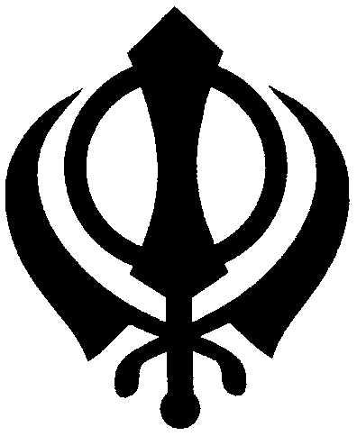

1. **Sikhism** is about 500 years old. It was founded By **Guru Nanak Deviji** in the **Punjab** (now part of Pakistan). The first guru was followed by 9

successors. Sikhs believe in one god, the teachings of the 10 gurus and the **Gura Granth Sahib**, the Sikh holy book.

2. Sikhs must wear the **Panj Kakke** or **5 Ks**. The 5Ks are: **Kesh** – uncut hair covered by a scarf or Turban; **Kangha** – a comb to keep the hair tidy; **Kara** – a steel bracelet; **Kirpan** – a small sword for self protection or to protect others who cannot protect themselves and **Kachera** – undergarments

similar to shorts. Some Sikhs dress according to these 5 Ks and women often wear a sari or shalwar, kameez and chadar (a long wide scarf) although they do not have to wear a veil. However, some Sikhs have adopted western

dress code.

3. Many Sikhs are vegetarians; those who are not are prohibited from eating halal meat. For orthodox Sikhs, intoxicants are strictly forbidden. Traditional arranged marriages are in decline although it remains commonplace for potential partners to be introduced by family members.

4. The Sikh place of worship is known as a Gurdwara; shoes must be removed and heads covered.

5. Significant holy days are:

a. **Vaisakhi** (13 April) – New Year’s day in the Punjab (a fixed date based in the lunar calendar).

b. **Diwali** – festival of lights held at the start of winter commemorating the self sacrifice of Haur Govind against Moghul rule.

c. **Guru Nanak’s** birthday – the birthday of the first guru held in

November.

d. **Hola Mohala** – a 3-day festival held in spring with displays of physical strength and Martial Arts activities.